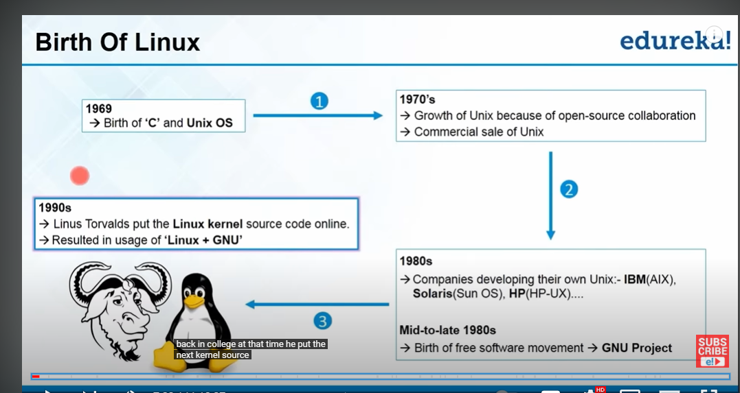

Dennis Ritchie and Ken Thompson's created the UNIX operating system and the C programming language at AT&T bell labs …..

Unix stands for: Uniplexed Information Computing System(UNICS)

What is Unix used for?

Unix is a multi-user operating system which allows more than one person to use the computer resources at a time. It was originally designed as a time-sharing system to serve several users simultaneous.

GNU project is all about people being able to access an operating system for free and you know developing an operating system for free

GNU is operating system and linux is the kernel that powers the operating system.

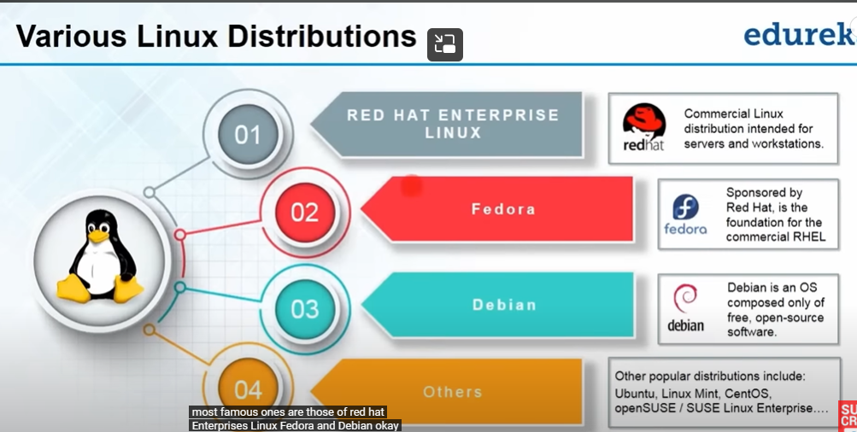

Redhat enterprise linux has free version is called “centos” redhat is very stable and very reliable…

Debian is not a company,where group of developers developing this version of linux version and ubuntu version

Ubuntu is the 3 rd most popular operating system….but it is not as fast as centos

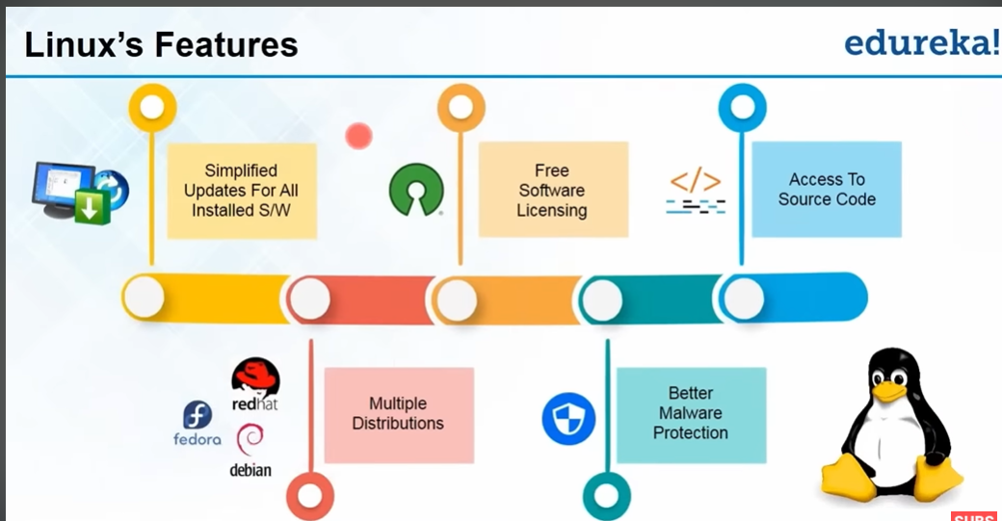

1.updates being easy to be performed…

CLI stands for commandlineinterface

Linux is free version of unix

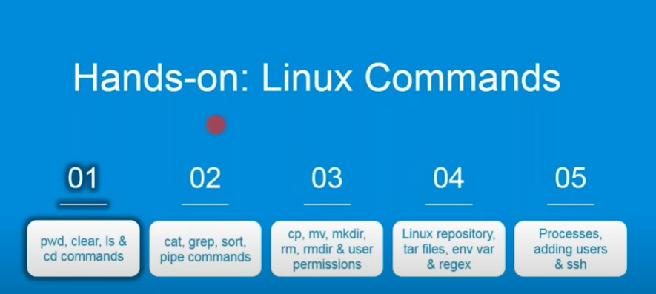

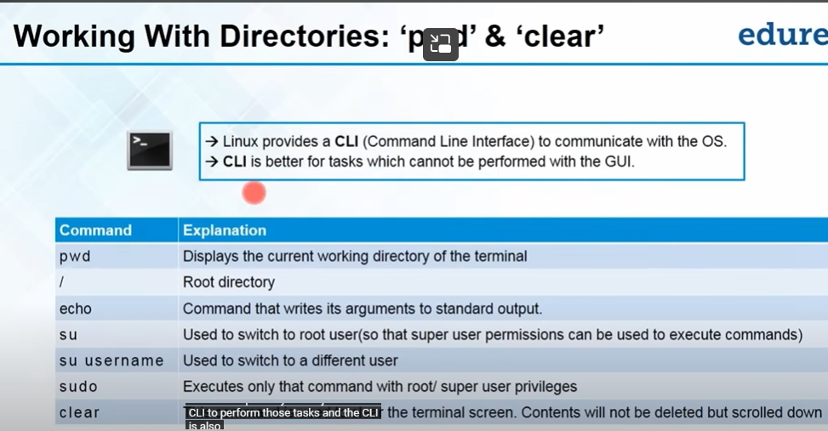

Pwd :It prints the current working directory………

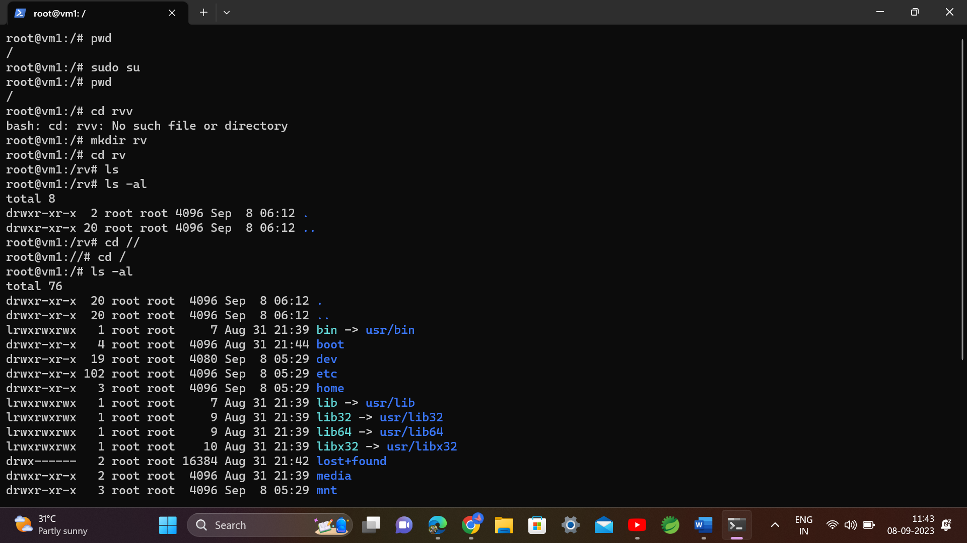

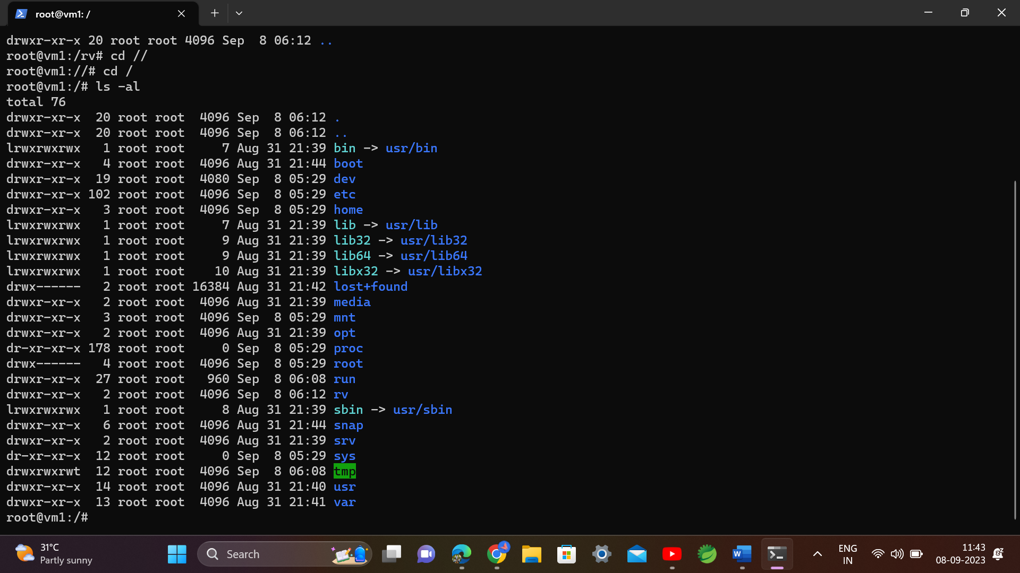

To go to previous directory command is cd..

Now if you want to one directory , you typed cd space some characters …and click tab ….it will be autofilled…

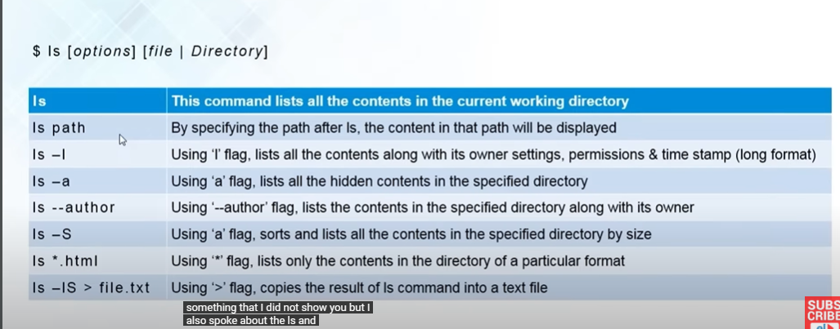

Cntrl +L or cntrl+l is the shortcut for clear screen

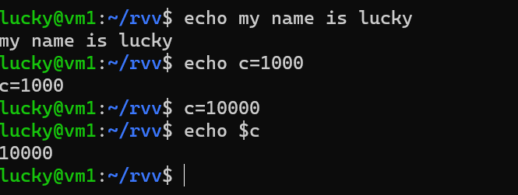

Su : switch to root user

Su username : switch to a specified user

Exit : to logout from the current user

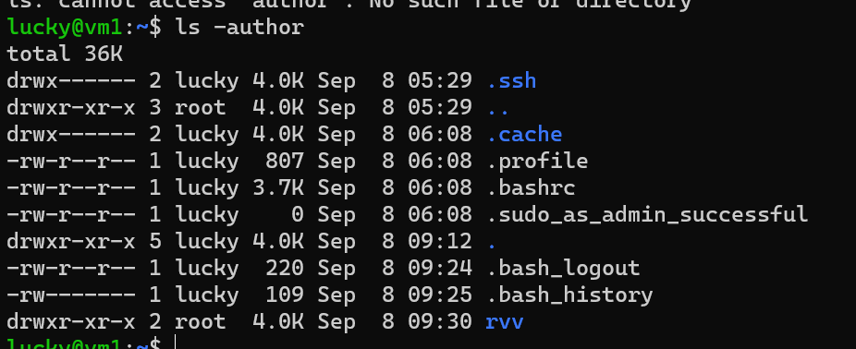

>symbol means all the data will be moved to the file1.txt(new file will be created)

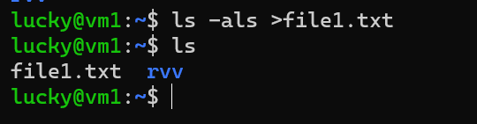

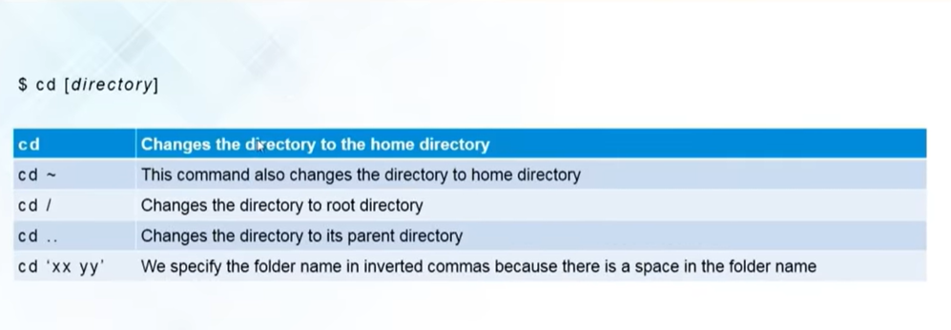

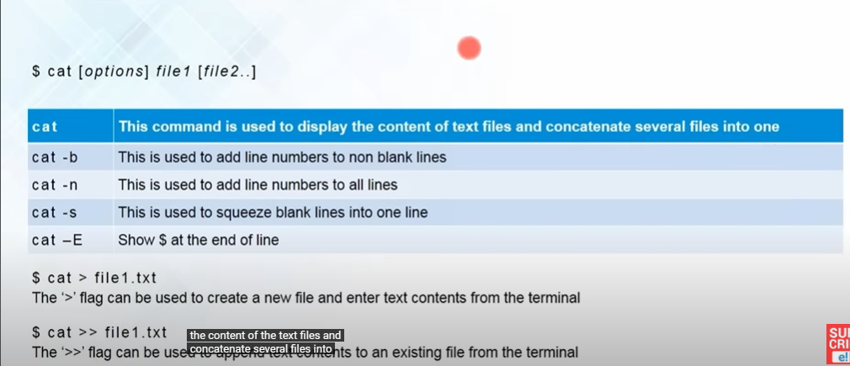

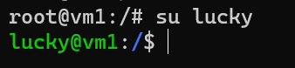

Cat command is used to display the contents of the file

To create a file cat > filename.txt….and write content in it then press cntrl+d

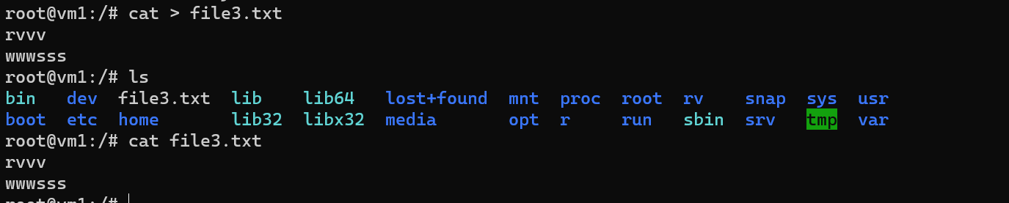

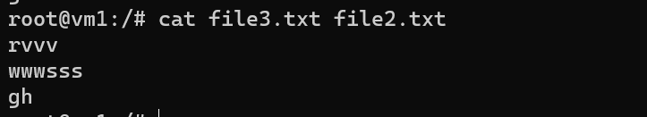

To concatenate files, using cat command

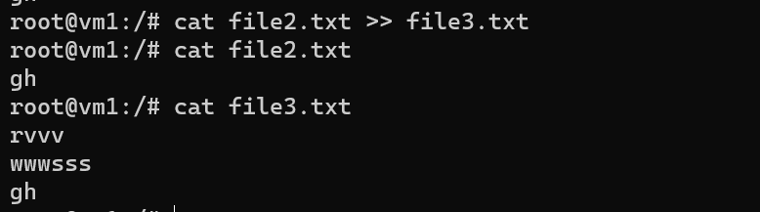

It will give the numbers to non empty lines

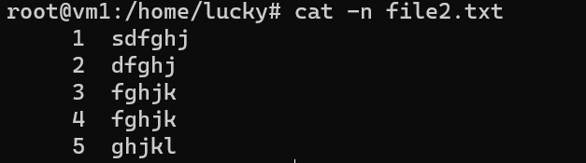

This is the difference between b and n flag

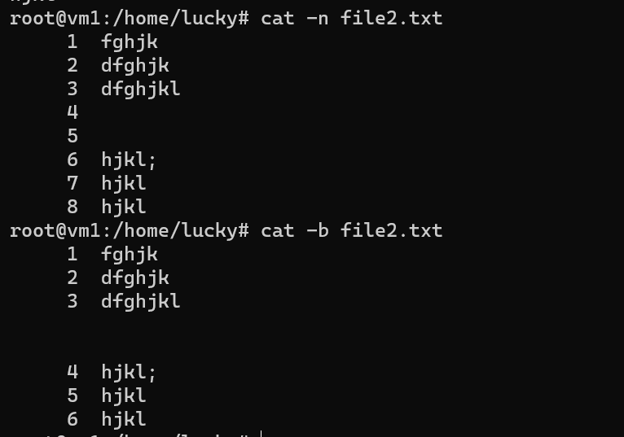

After the content written in vi editor, press esc+shift colon wq

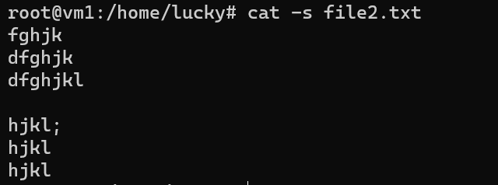

All the extra lines are reduced

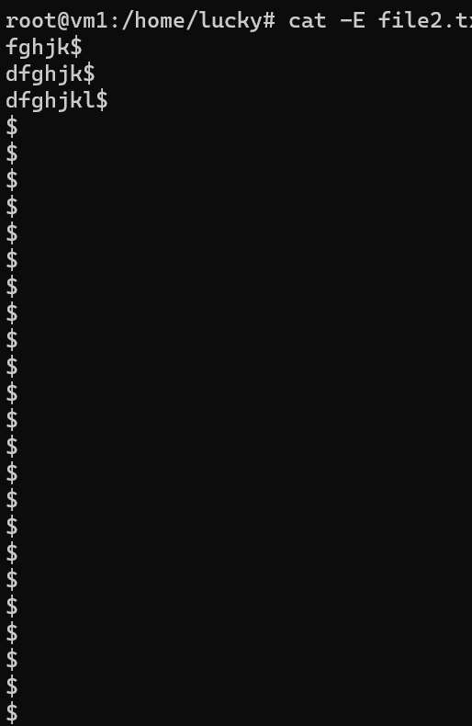

cat -E filename this command adds $ to the end of the line

cat >> filename.txt

Add contents to the existing file…

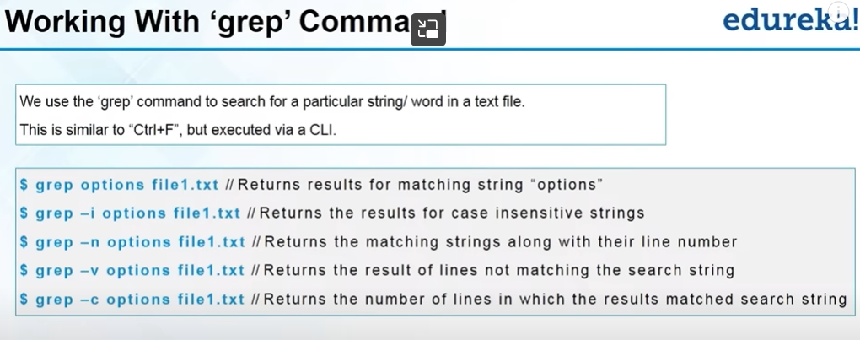

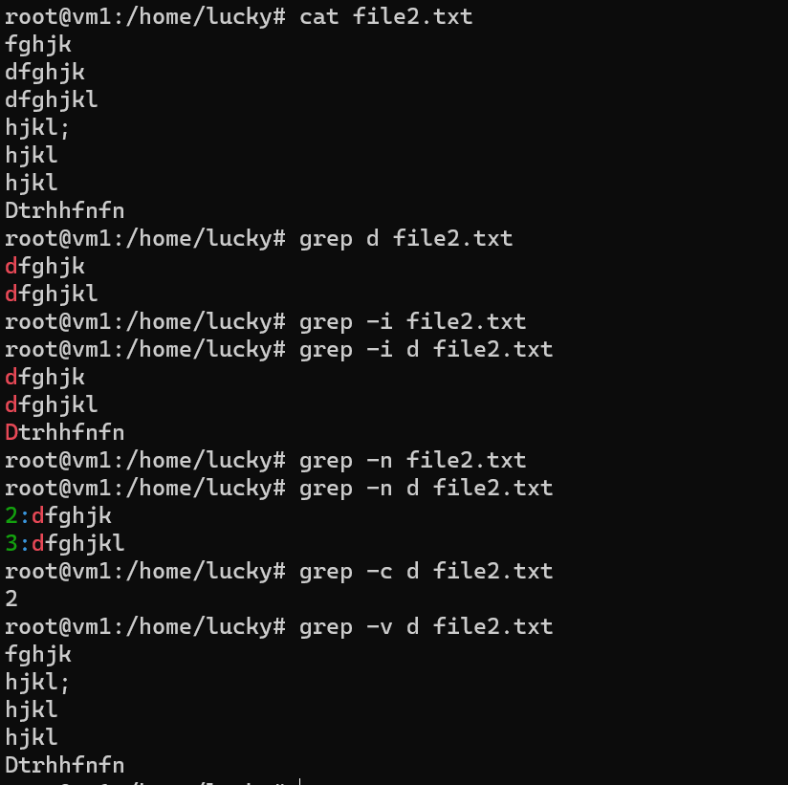

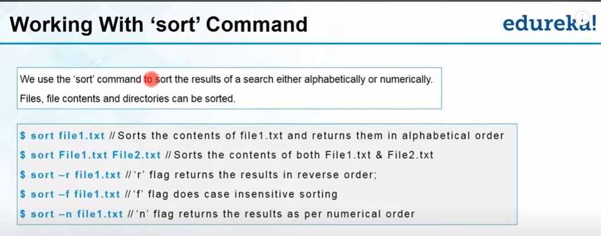

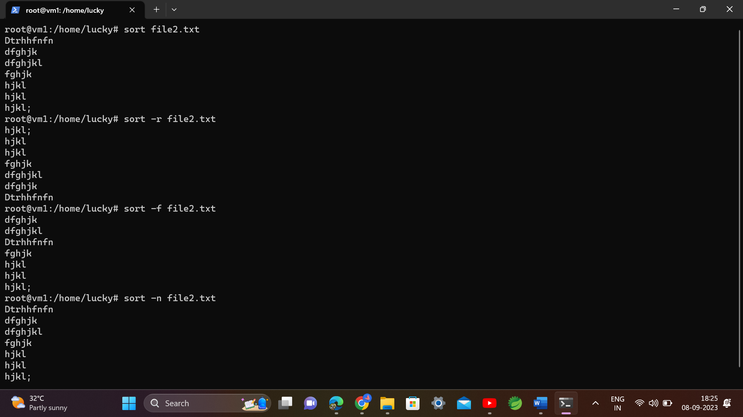

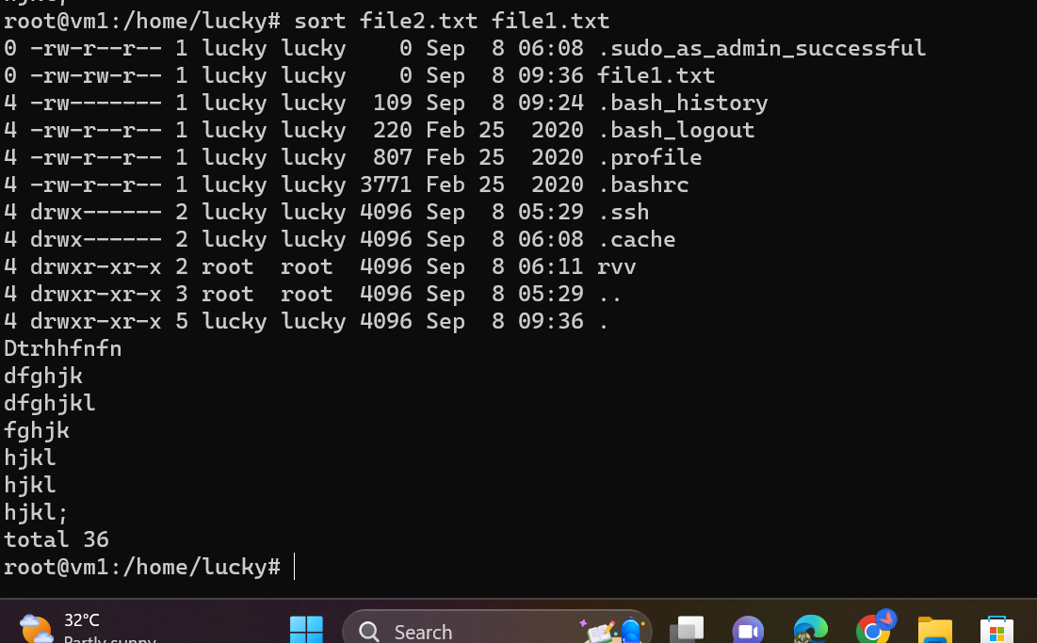

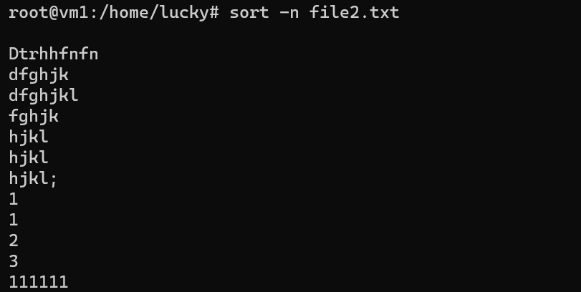

The pipe is used to combine 2 or 3 actions…

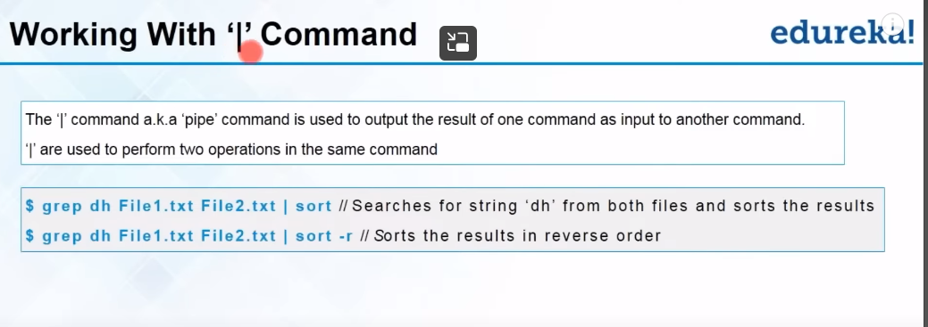

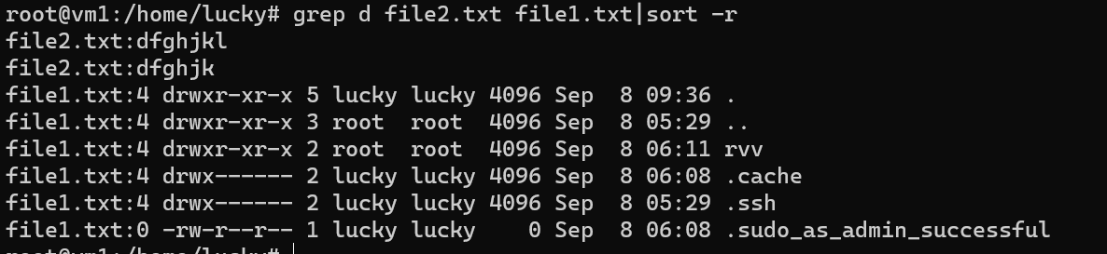

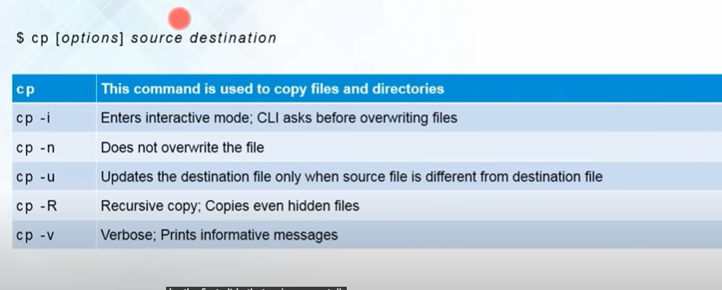

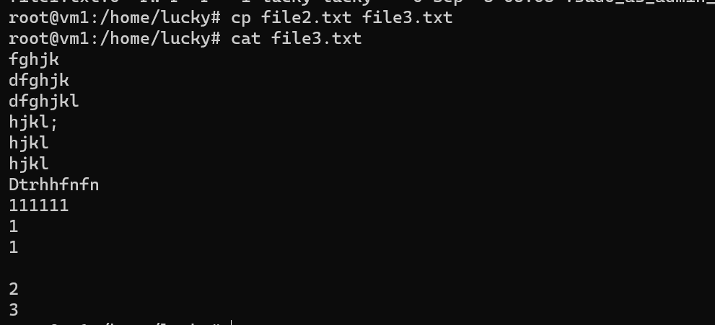

New file has created…

Actually cp is for copying files…but if you wanna copy directories….You have to mention it first and the command is

cp -R (source directory) destination



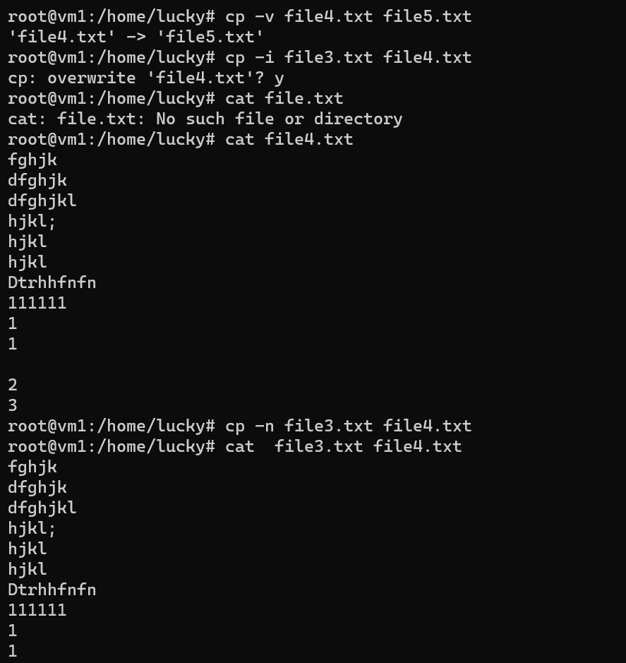

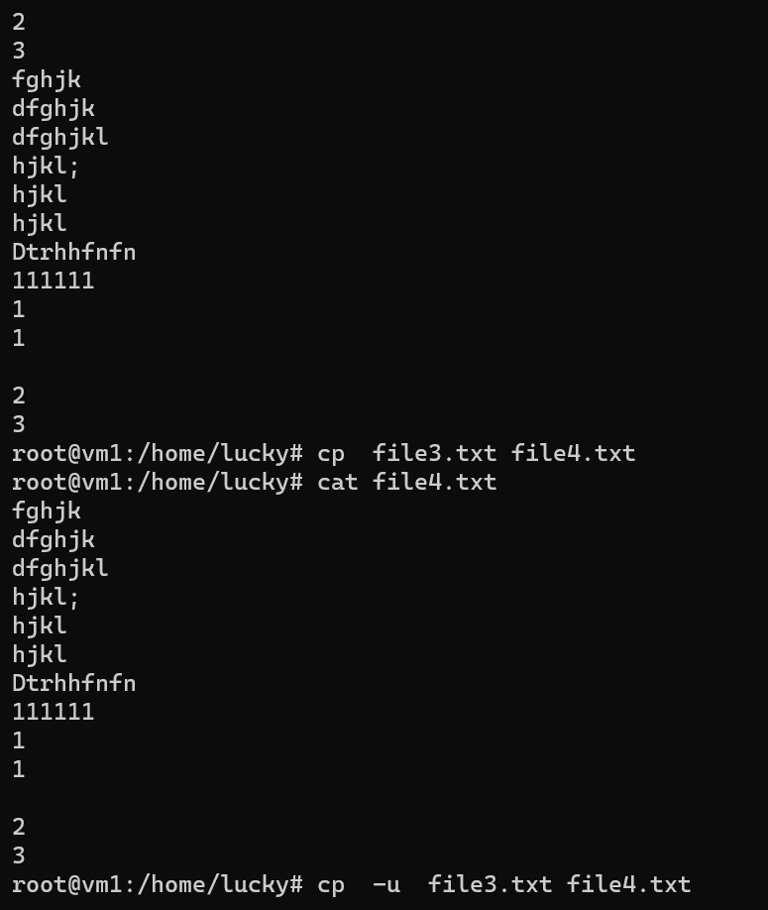

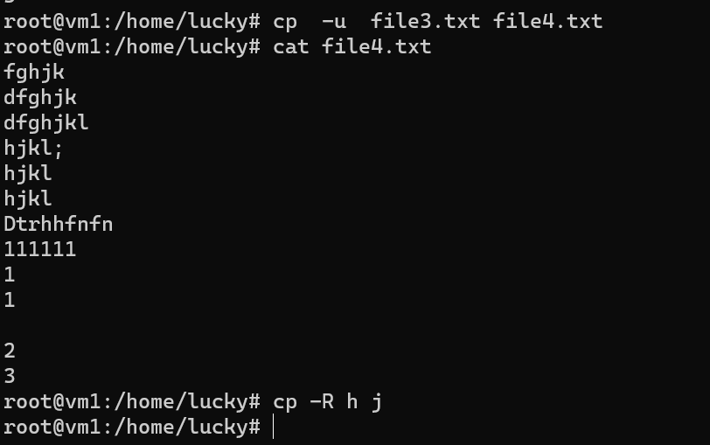

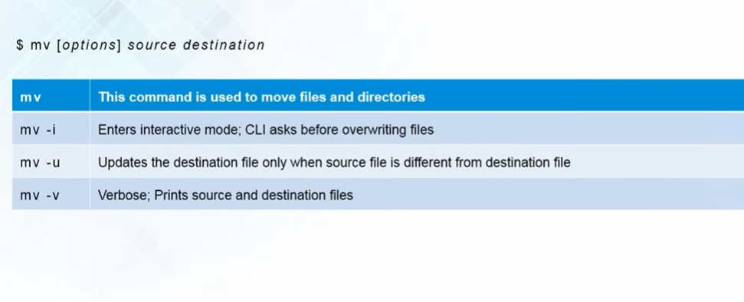

To view the content of a directory , use this command dir

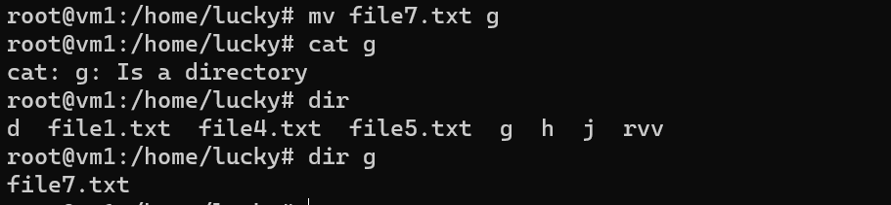

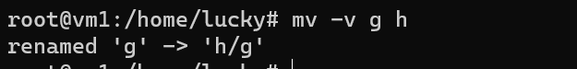

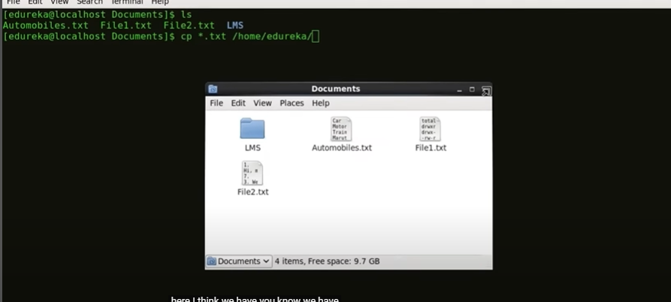

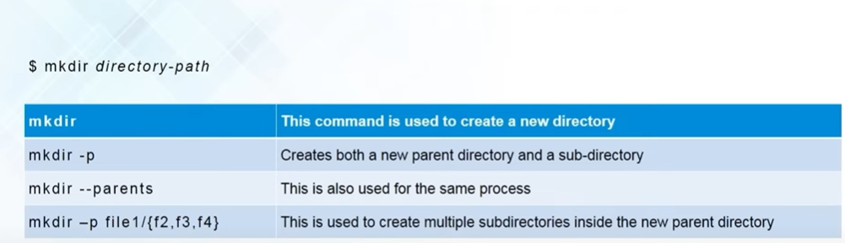

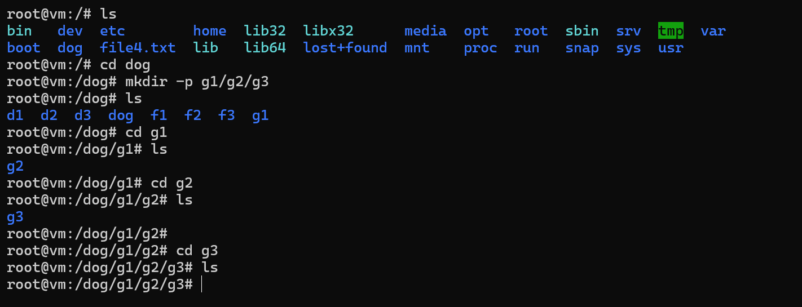

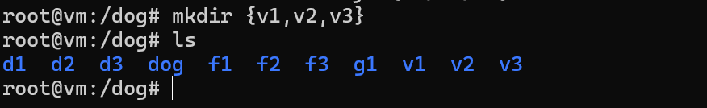

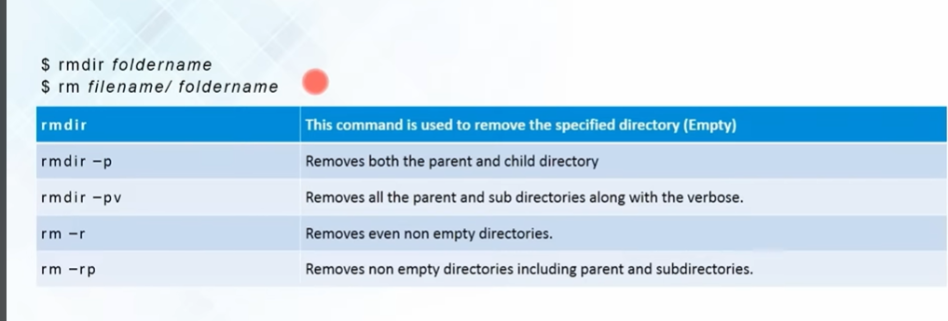

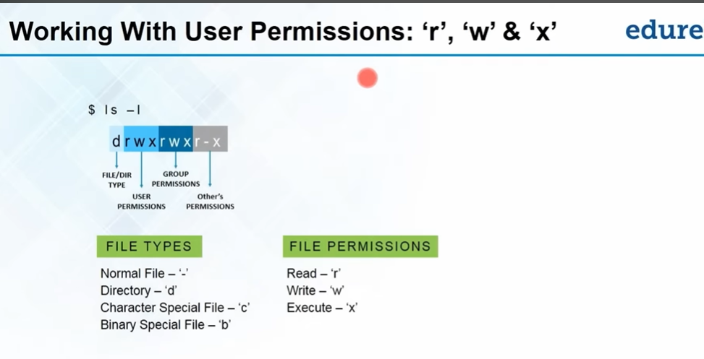

A user can create, delete, or modify the file. Group: A group can contain multiple users. All the users belonging to a group have same access permission for a file. Other: Any one who has access to the file other than user and group comes in the category of other.

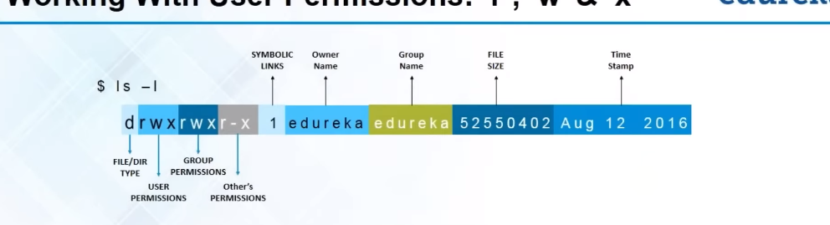

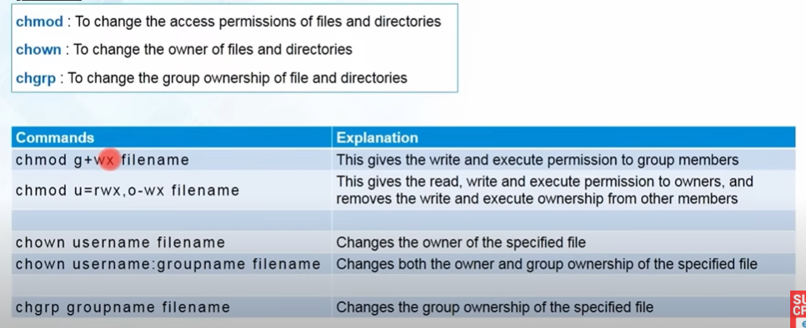

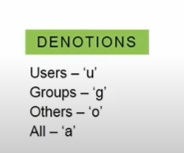

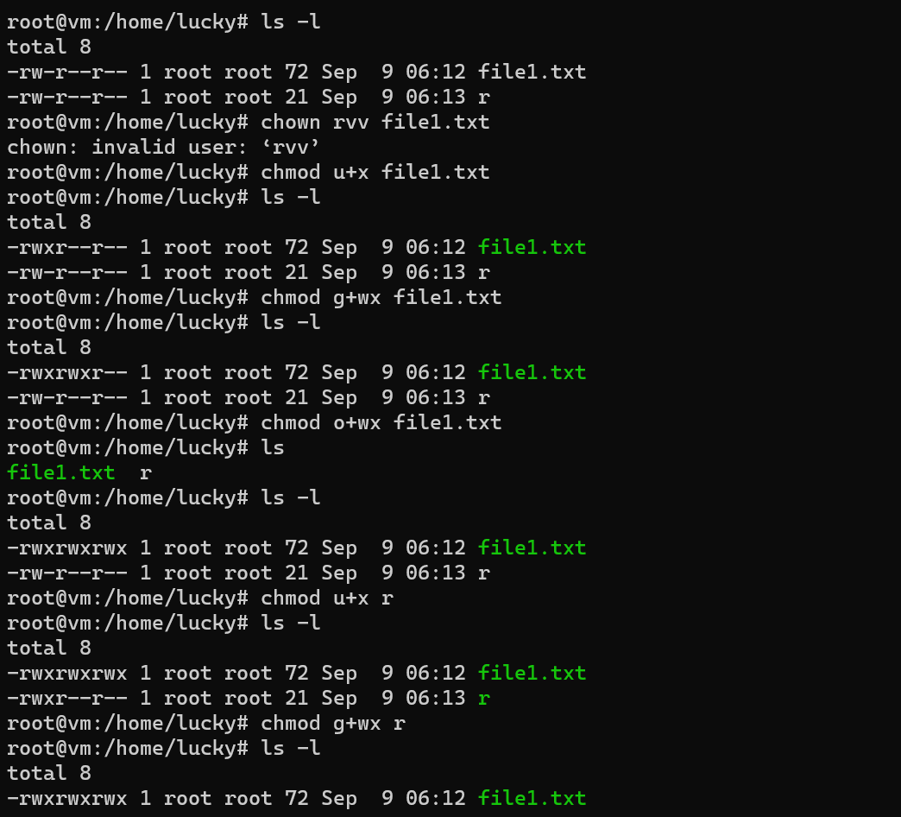

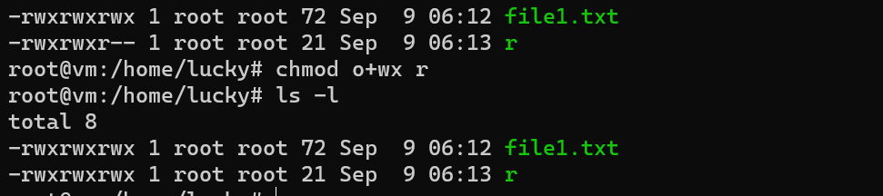

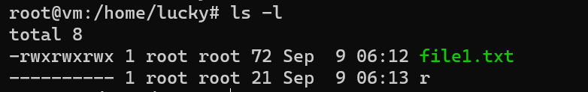

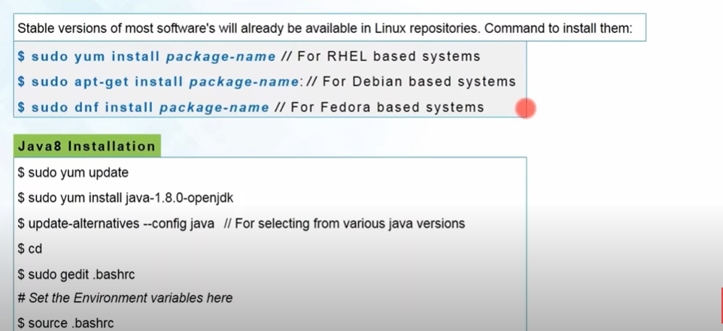

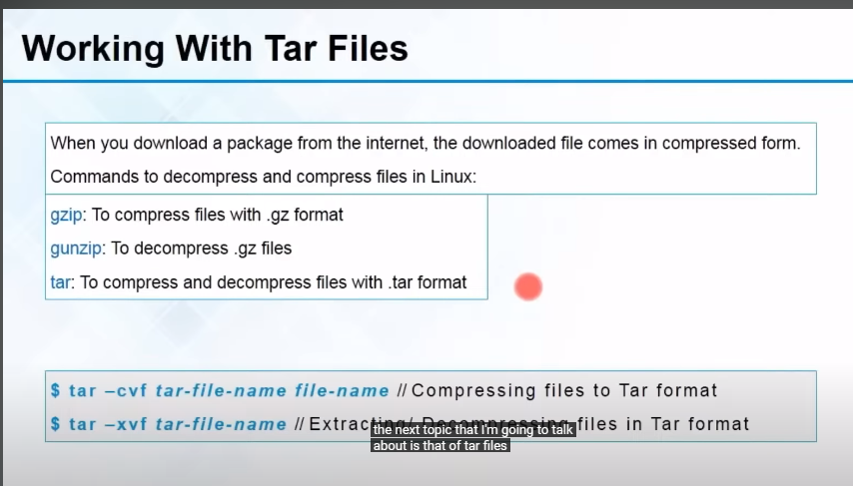

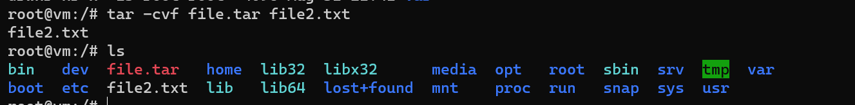

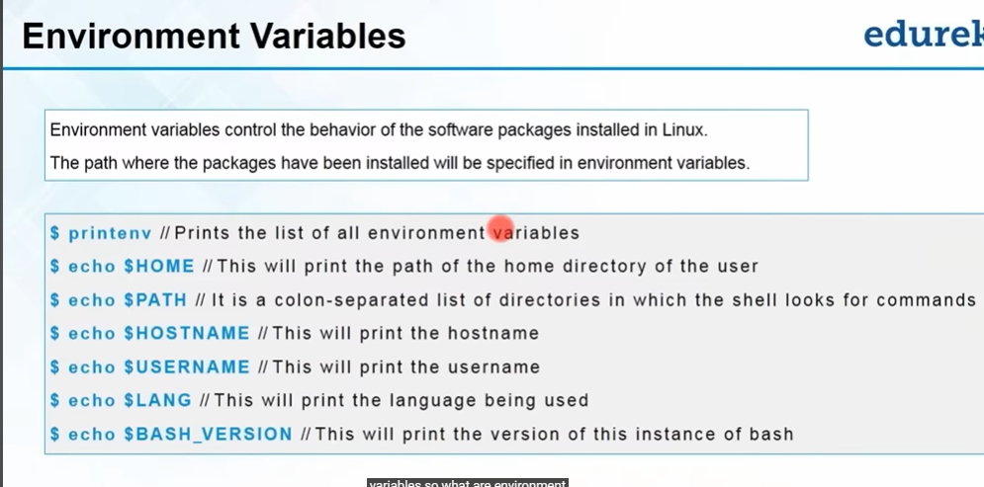

1. Move the cursor to the end of the file where you want to add your environment variable.
2. Add a new line and define your environment variable. For example:

export MY_VARIABLE="my_value"

Replace **"MY_VARIABLE"** with your desired variable name and **"my_value"** with the value you want to assign to it.

1. After adding the environment variable, save the changes by pressing **Ctrl+O**, then press Enter to confirm the filename to write. You may be prompted to confirm the save.
2. To exit Nano, press **Ctrl+X**.

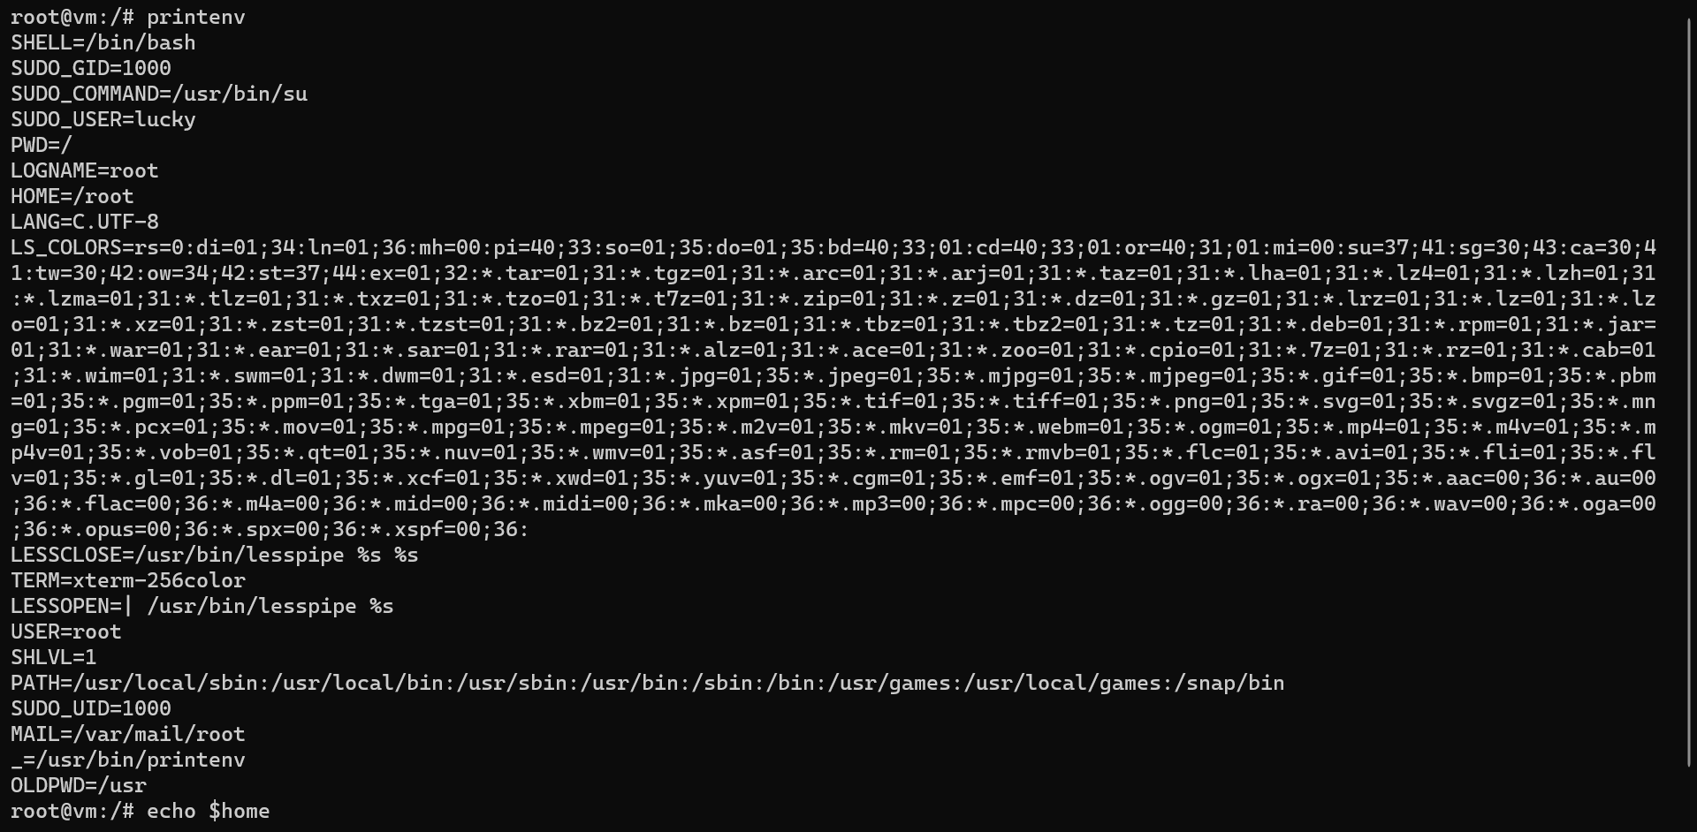



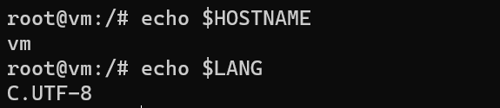

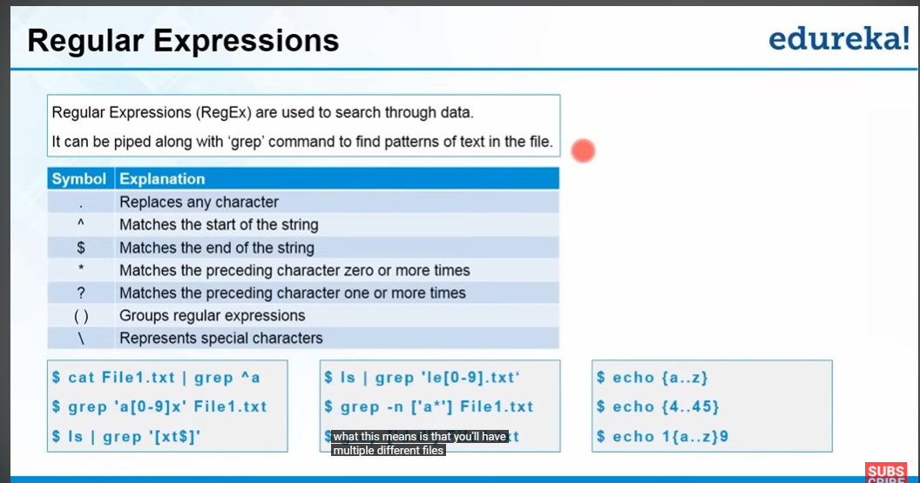

Re is used to search through patterns of data

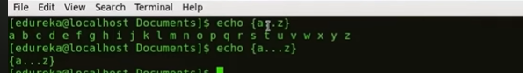

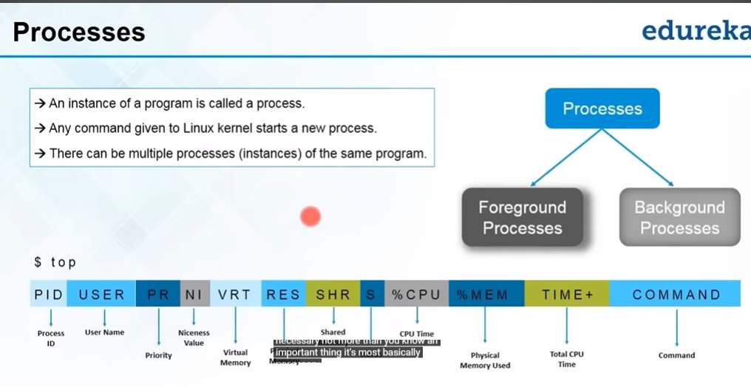

he top command is useed to show the active Linux processes

Pid for user id

Kill for kill the process…

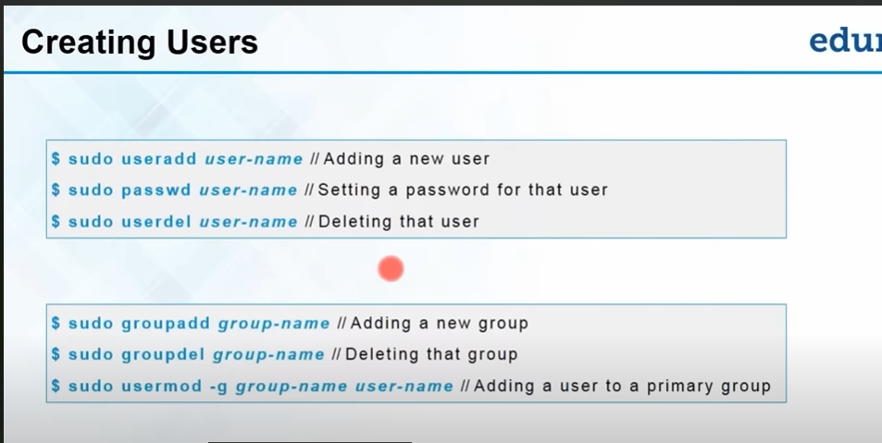

Be cautious when using the **-9** option, as it forcefully terminates the process without allowing it to clean up resources. Only use this option if you have no other choice.

sudo kill -9 27711

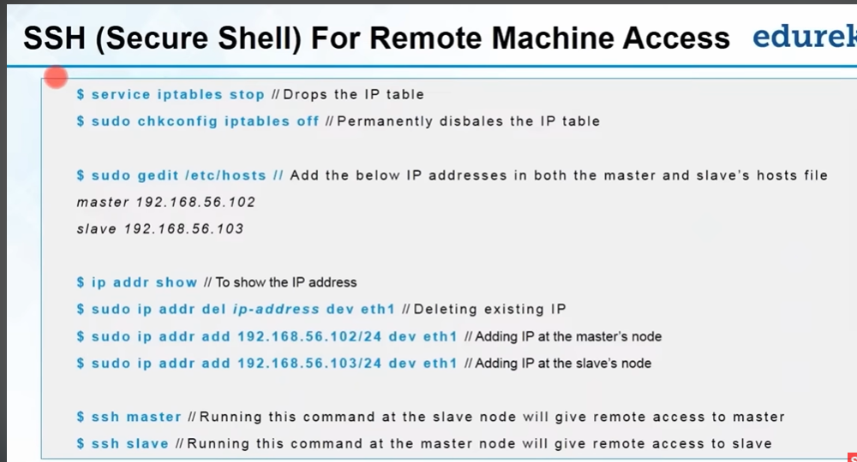

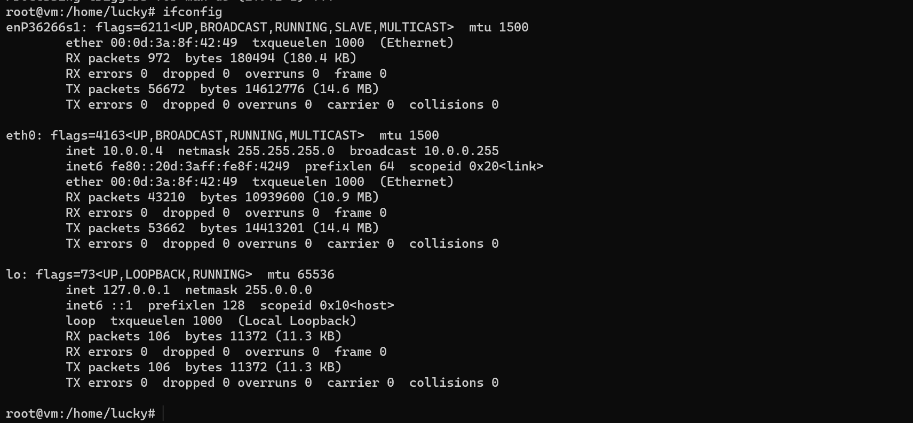

You can use the ifconfig command to assign an address to a network interface and to configure or display the current network interface configuration information. The ifconfig command must be used at system startup to define the network address of each interface present on a system.

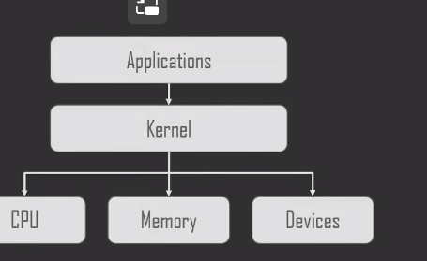

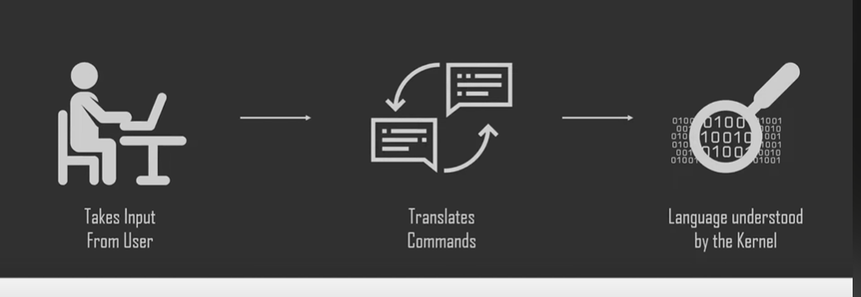





|upward shell|THE MODERN SHELL

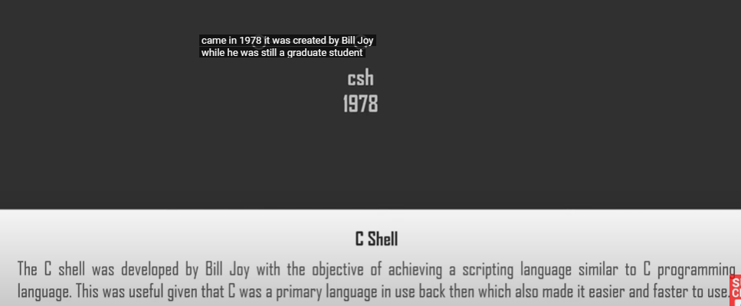

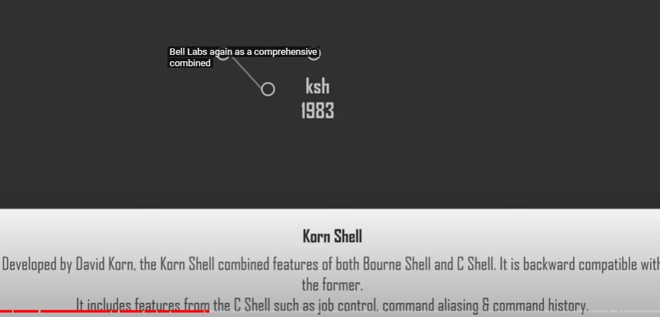



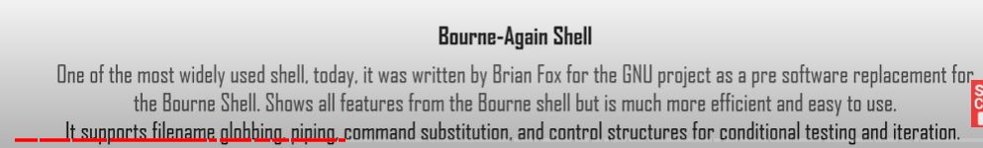

1989 -> Bourne again shell



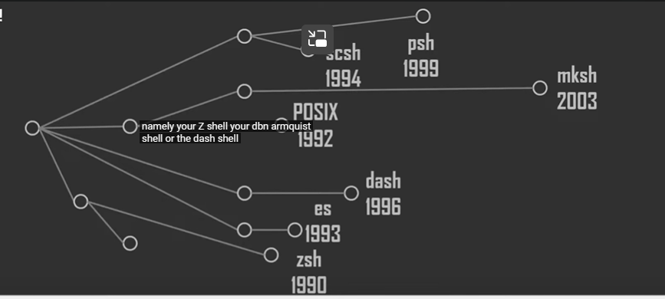

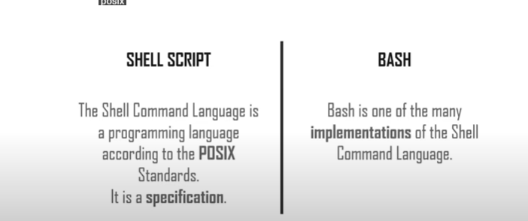

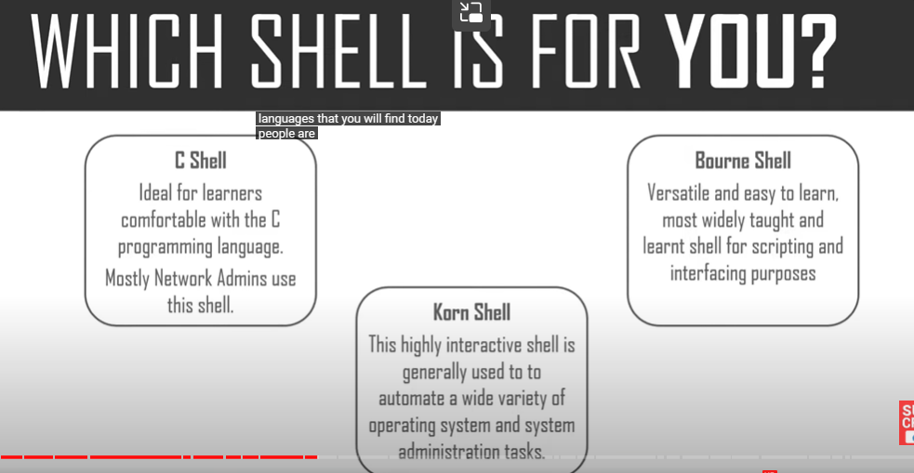

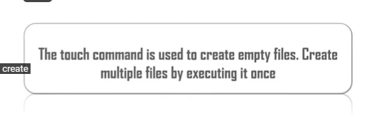

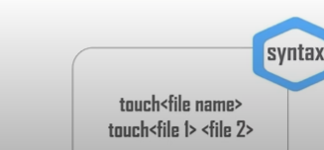

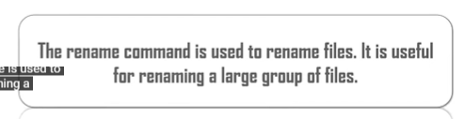

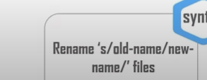

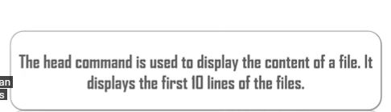

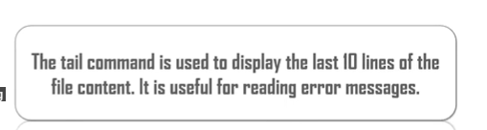

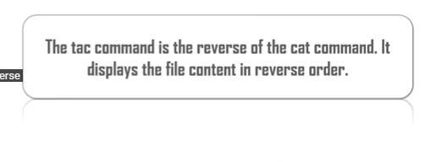



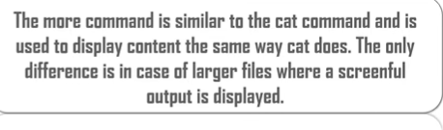

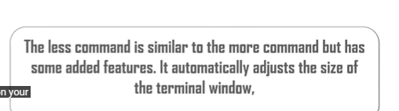

Less filename

More filename

